Config
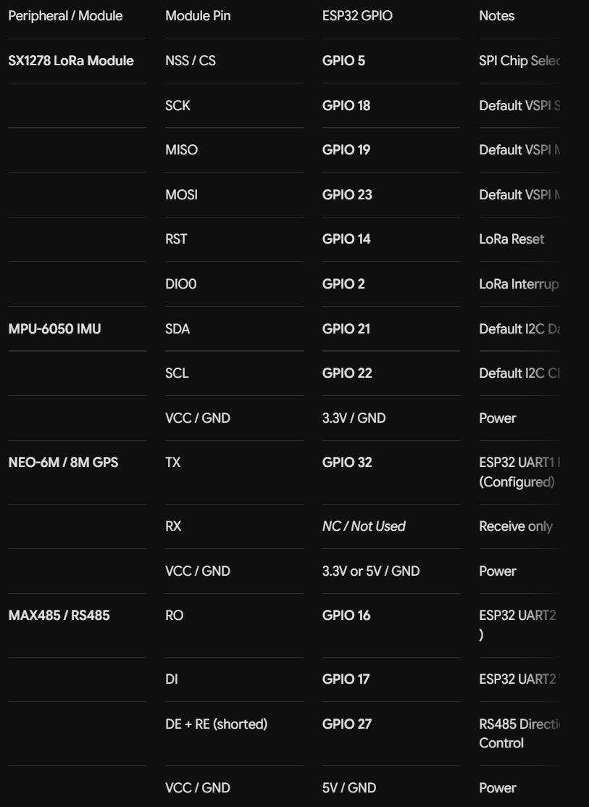
Payload structure:
DATA:<ID>,SATS_LOCKED,SATS_VIEW,LAT,LNG,SPD,AX,AY,AZ,GZ,SOIL_OK,T,M,EC,PH,SAL,N,P,K
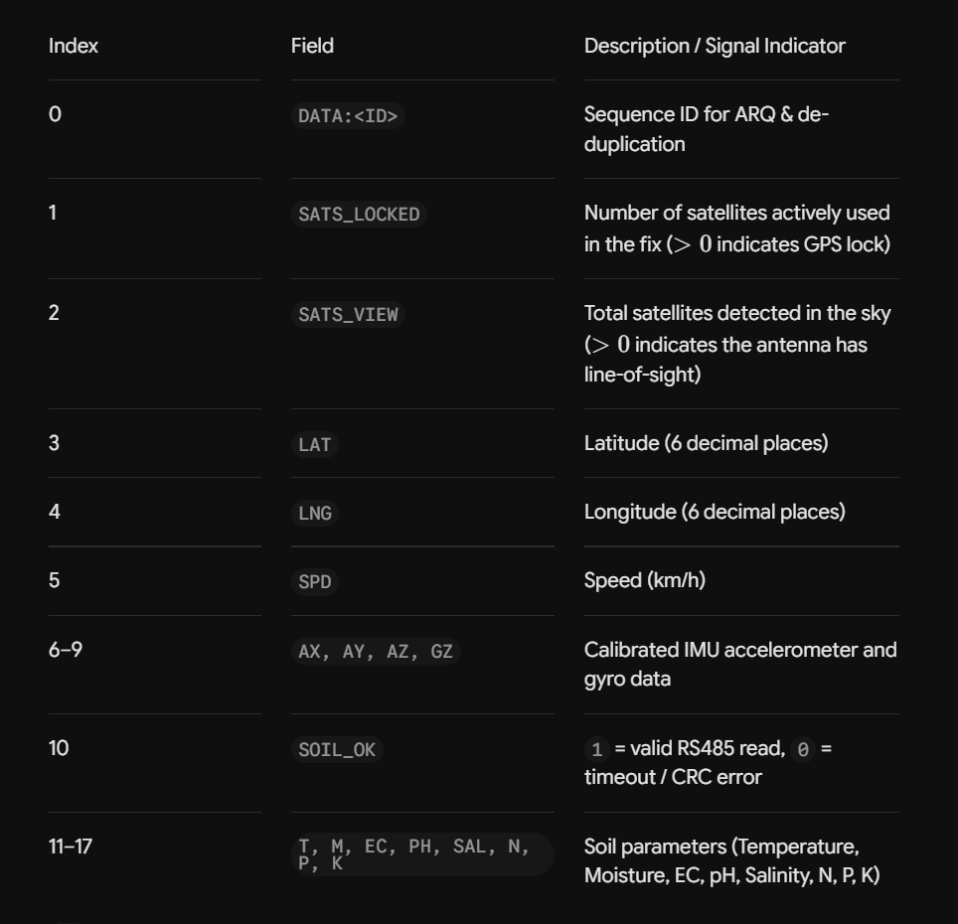

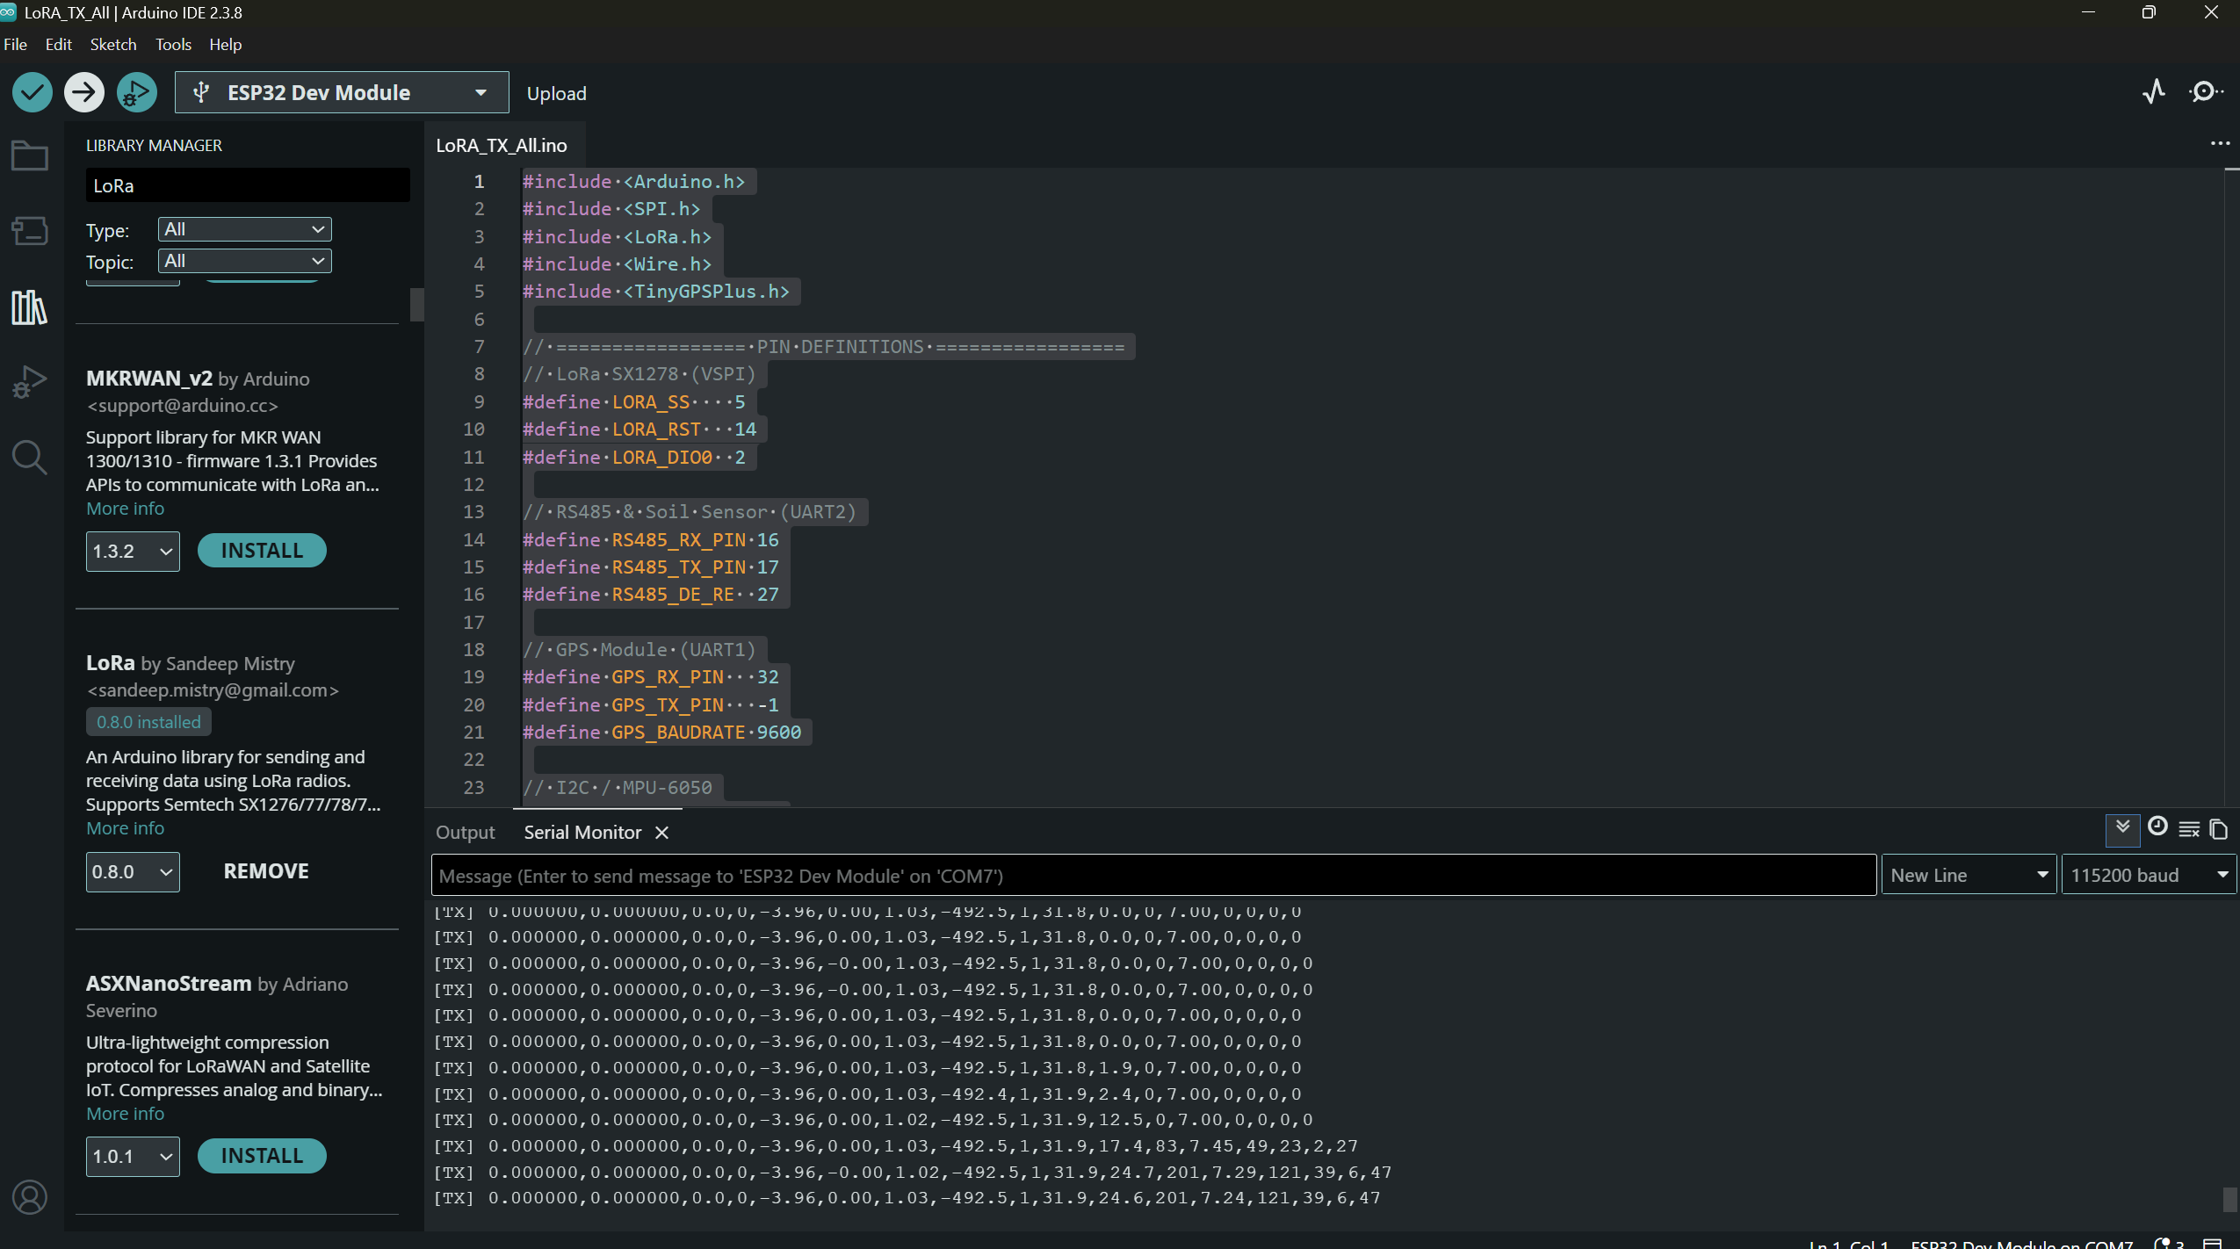

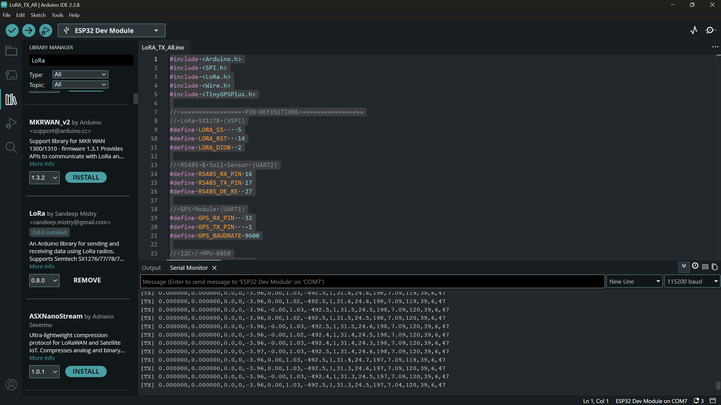

tx rx activated
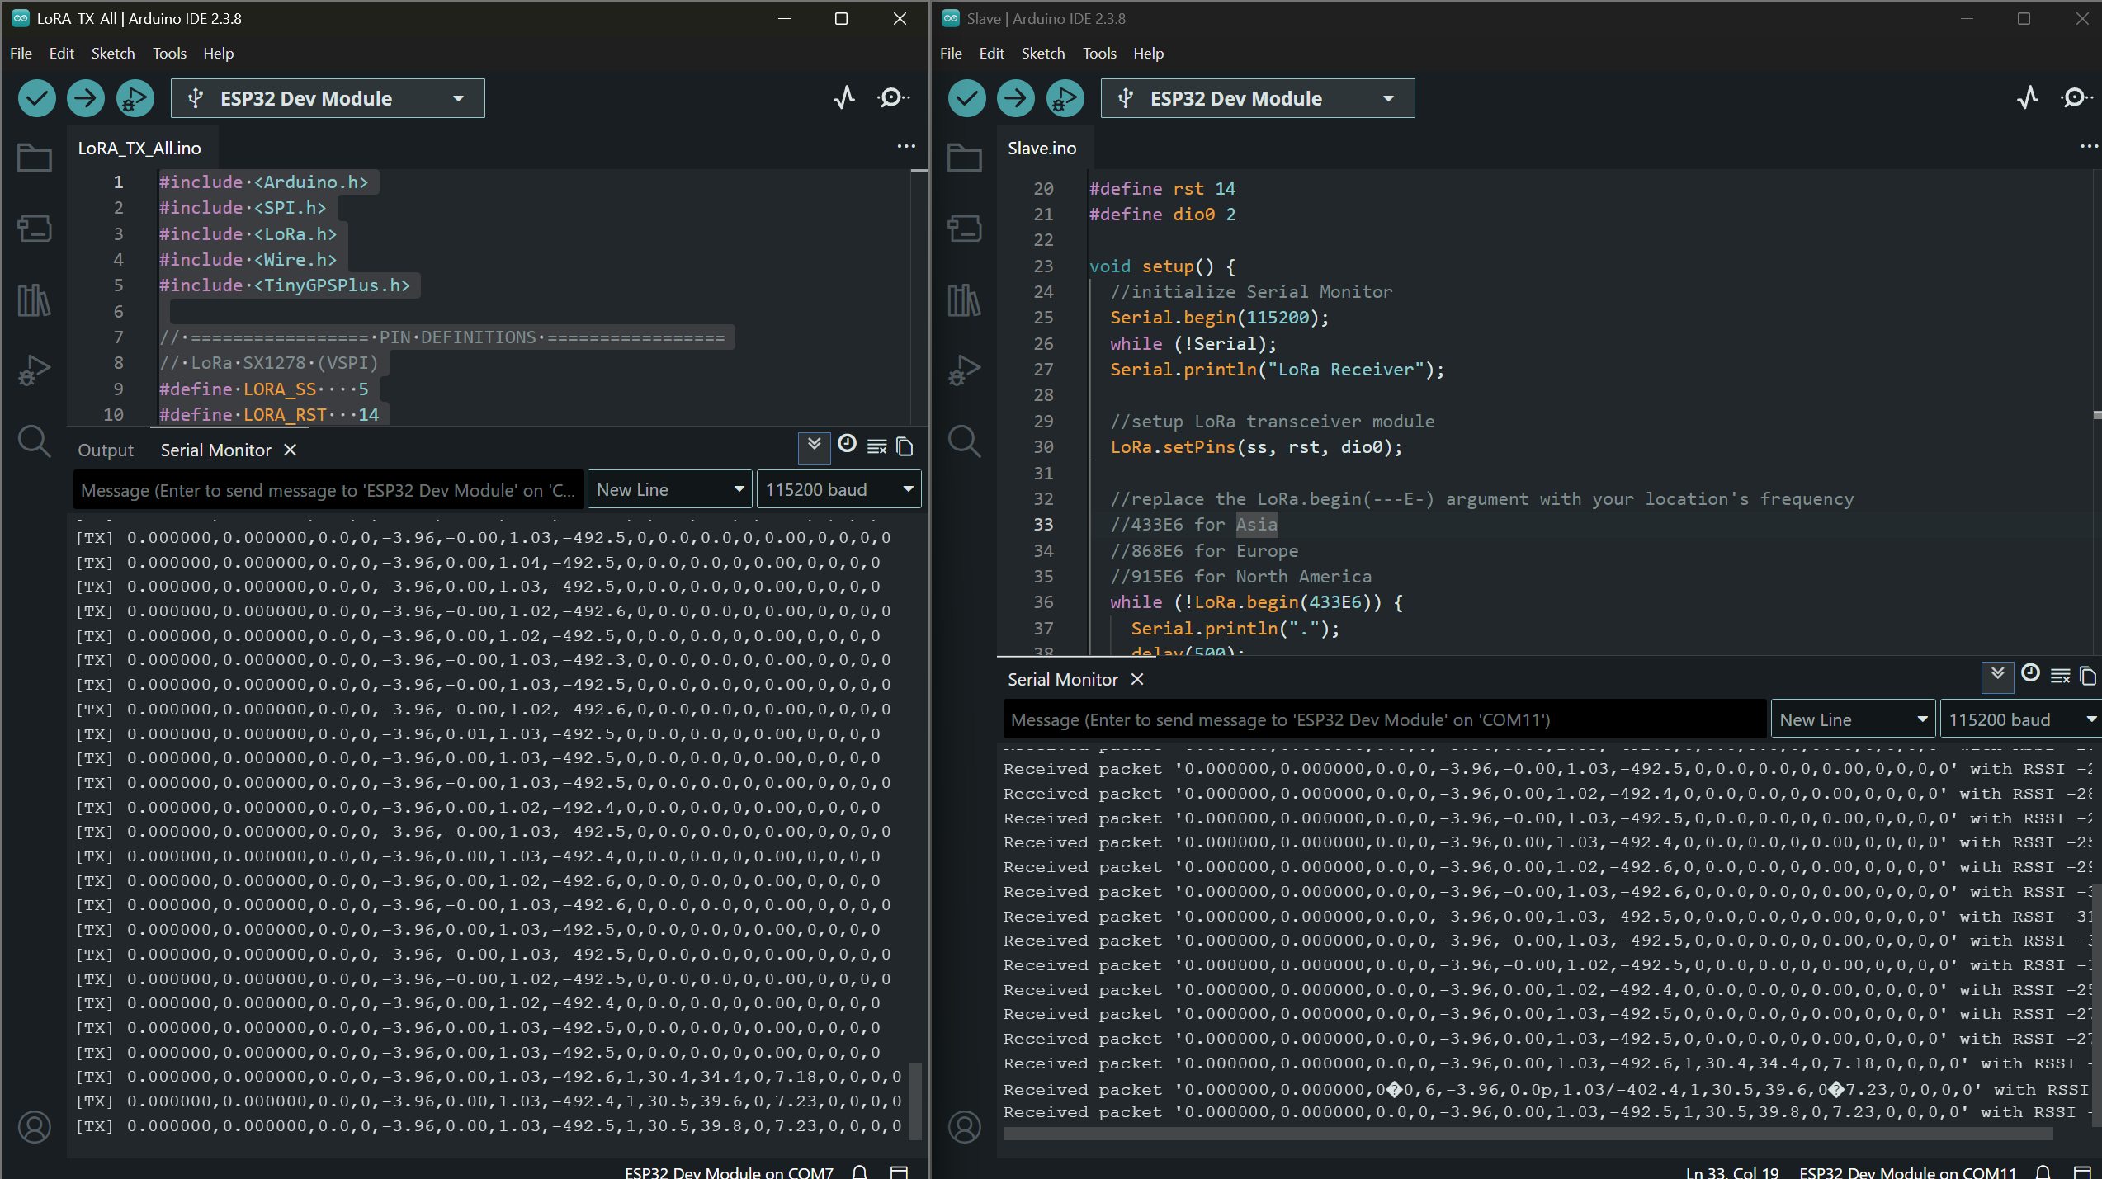
Observation: Some data are getting corrupted.

After applying integrity validation, packet acknowledgement, and retransmission effect:
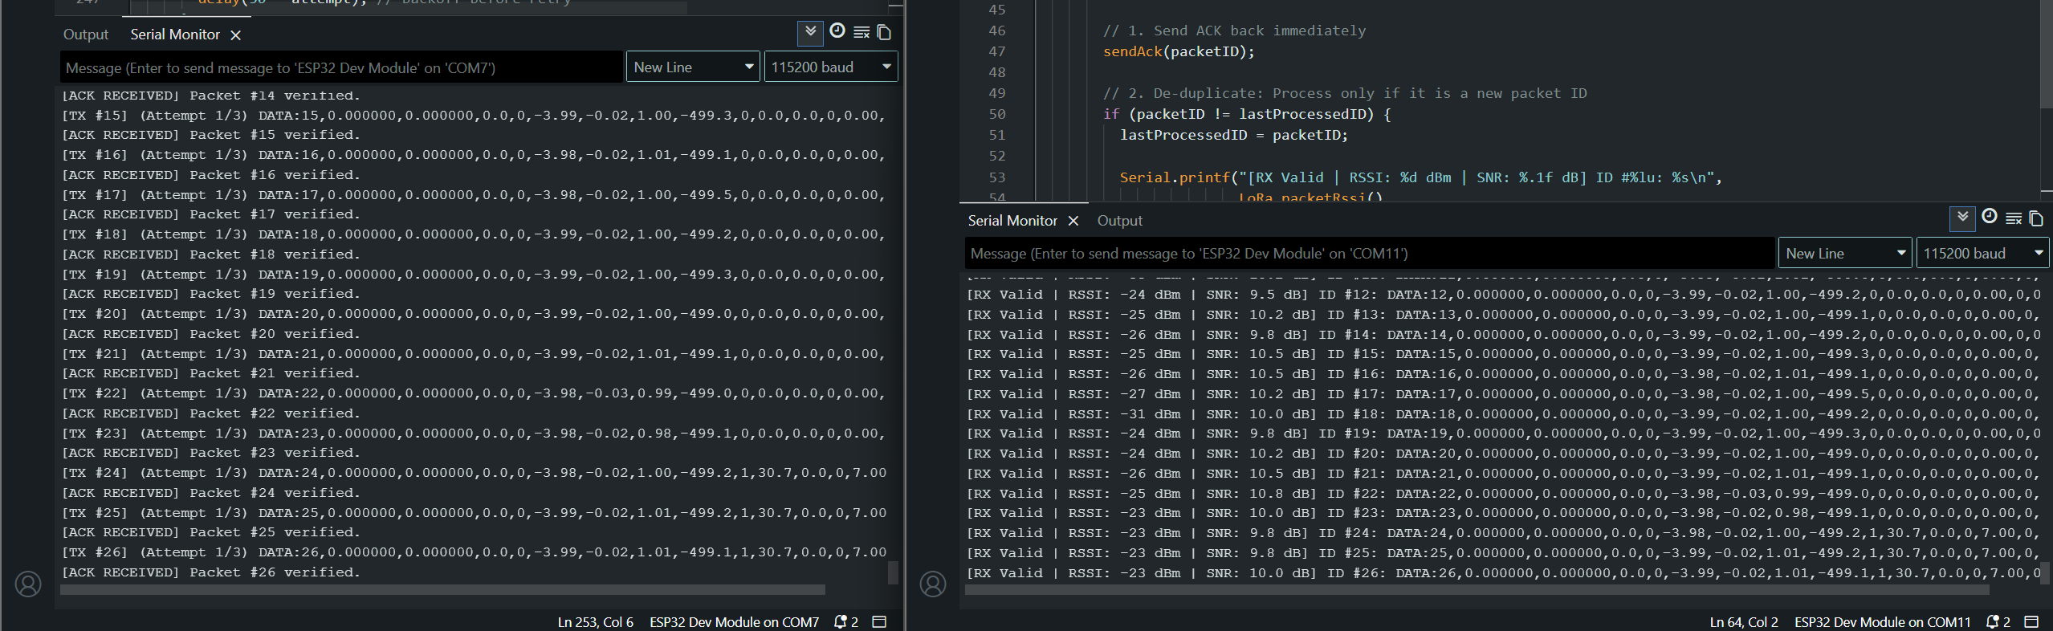

When receiver is disconnected or cannot receive:
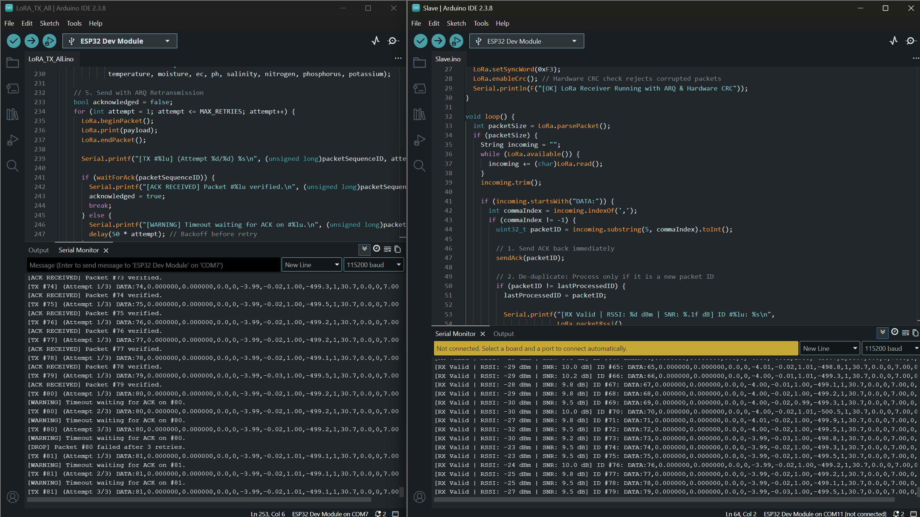

After reconnection:
